Warm Up

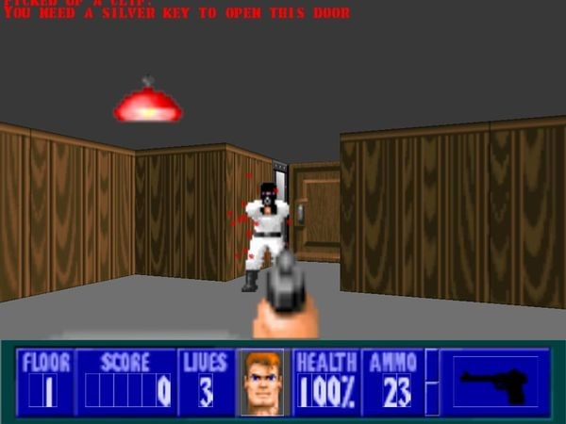

What do you think are the differences between 2D and 3D games?

|  |
| --- |